## horizontal line

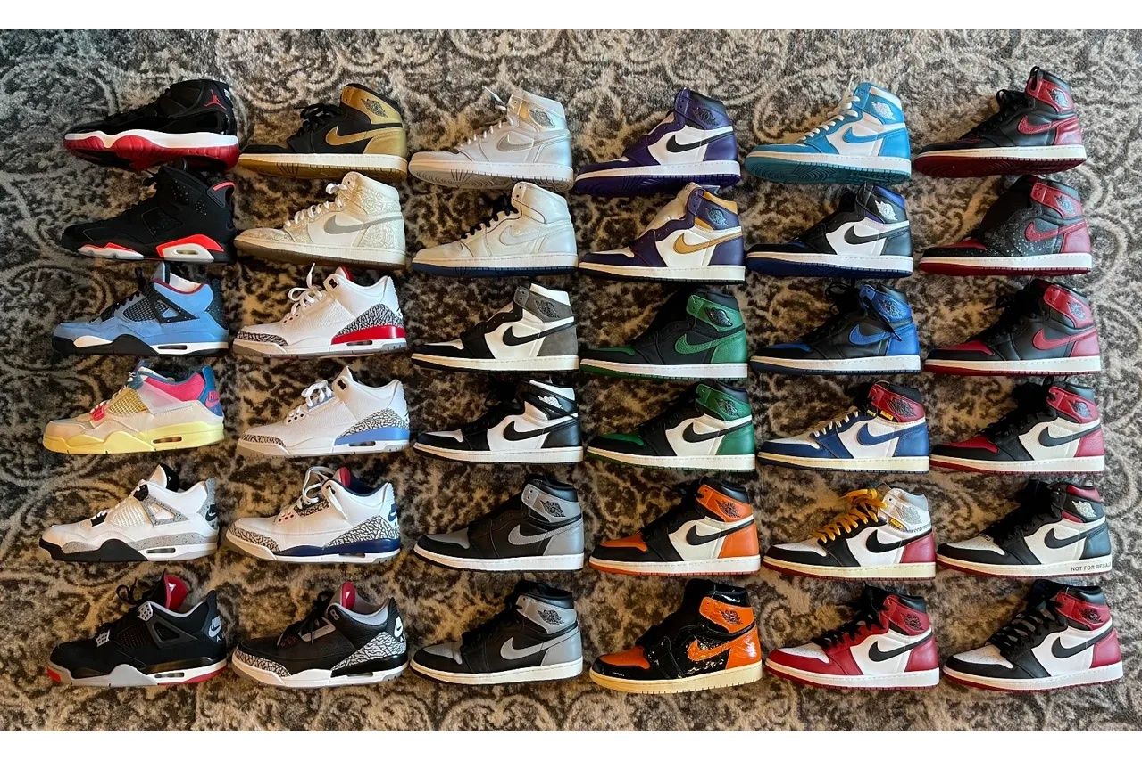

Your Sneaker Collection

08.22.2022

**─**

Troy Jones

Kelvin Corporation

2711 Lyndon B Johnson Fwy Suite 450

Dallas, TX 75234

# Overview

The Your Sneaker Collection website will provide users a site on which to share their love for athletic sneakers.

# Goals

1. Deliver a desktop browser functional **(V1)** website by September 2nd.
2. Deliver a two to three minute presentation describing the website’s functionality and construction.

# Specifications

**MVP (V1) - focus: proof of concept**

* Website will work on the targeted device which is a web browser for V1 - **50% complete.**
* Website will have a responsive web design targeted to a browser - **60% complete.**
* Users will be able to register via the landing page - **90% complete**.
* Users’ passwords will be encrypted using the (Argon2 - first choice, Bcrypt - second choice encryption algorithm - **complete for bcrypt**
* Users will be able to view all shoes in the sneakers database - **starting this week.**
* Sneaker data will be extracted from the web using a web crawler api and seeded into the sneaker database - **complete**
* Sneaker data will include a picture, price & description of the shoe - **starting this week.**

**V2 - focus: infrastructure and security**

* Application logs errors to cloud logging provider e.g. Rollbar or similar.
* API’s deployed to Heroku.
* Website client and server deployed to yoursneakercloset.com.
* APIs require authentication via Amazon, Google Cloud, etc.
* Application provides secure login via SSL and website’s certificate information displays in a banner within the footer.

**V3 - focus: features and user feedback**

* Users can create a sneaker closet and assign sneakers to his/her closet.
* Users can view current price information of the shoe from multiple websites.
* Users can share his/her virtual sneaker collection with other users.
* Users can create a wishlist of desired sneakers.
* A User’s sneaker closet will estimate the resale value of his/her sneaker portfolio.
* Users can view/interact with the website on a mobile device.
* Sneaker data api will update data at more regular intervals. Possible performance improvements to the data extraction process.
* Other features as determined from user feedback.

# V1 Milestones

## **Website Design Language - complete**

The design language of the website has been identified. Samples are included at the end of this document. A prototype landing page is currently running at [yoursneakercollection.com](http://yoursneakercloset.com).

## **Data - complete**

Database model is complete. Web crawler successfully loaded ~500 sneakers into the Sneaker Database.

## **User Interface - in progress. Deadline: 8/30**

Landing page complete. Login page complete. TBD - “HTML, JavaScript and CSS for view all sneakers” page for MVP.

## **Back-End Service - in progress: Deadline 8/30**

Work continues on migration from bcrypt to argon. Will abandon argon if problems arise. Basic workflow of user authentication verified. Need to develop an api to return shoe data to the browser for the “view all sneakers” page.

## **Deployment - TBD**

This is more of a nice to have for **V1** but critical for **V2**. Ideally, client and server code exist in their entirety at yoursneakercollection.com. Additionally, the api’s are hosted on Heroku. To complete this milestone the build in its entirety exists is deployed to the godaddy website.

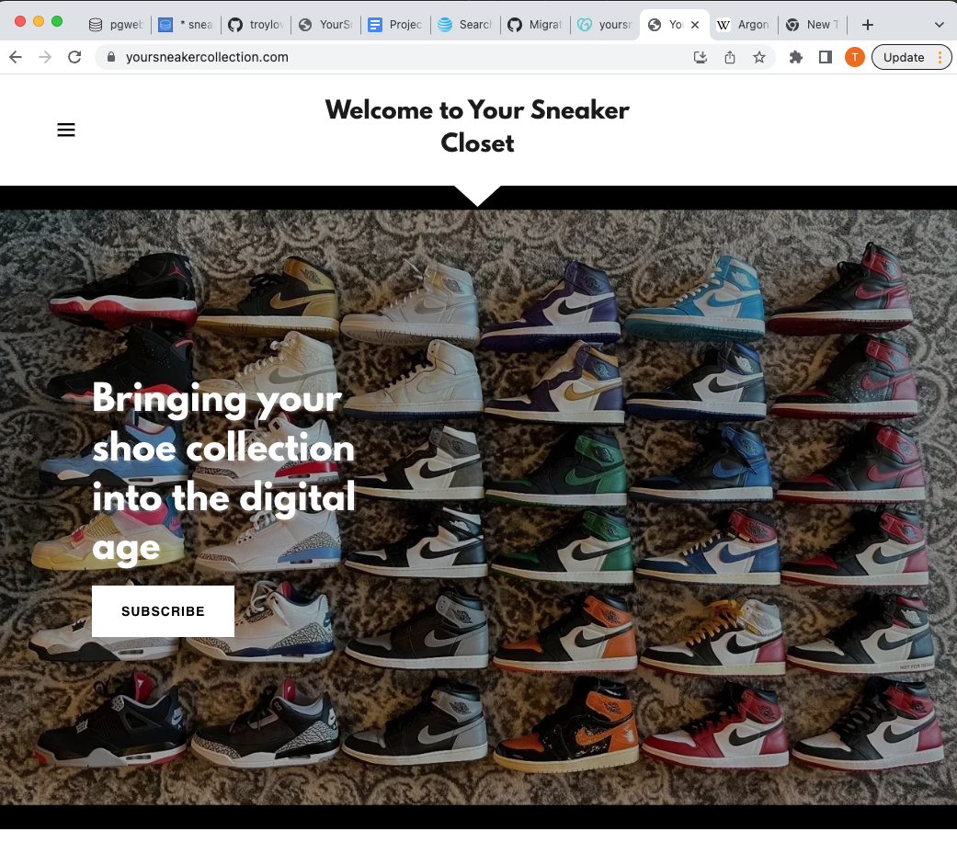

**Figure 1: The design language of the website.**

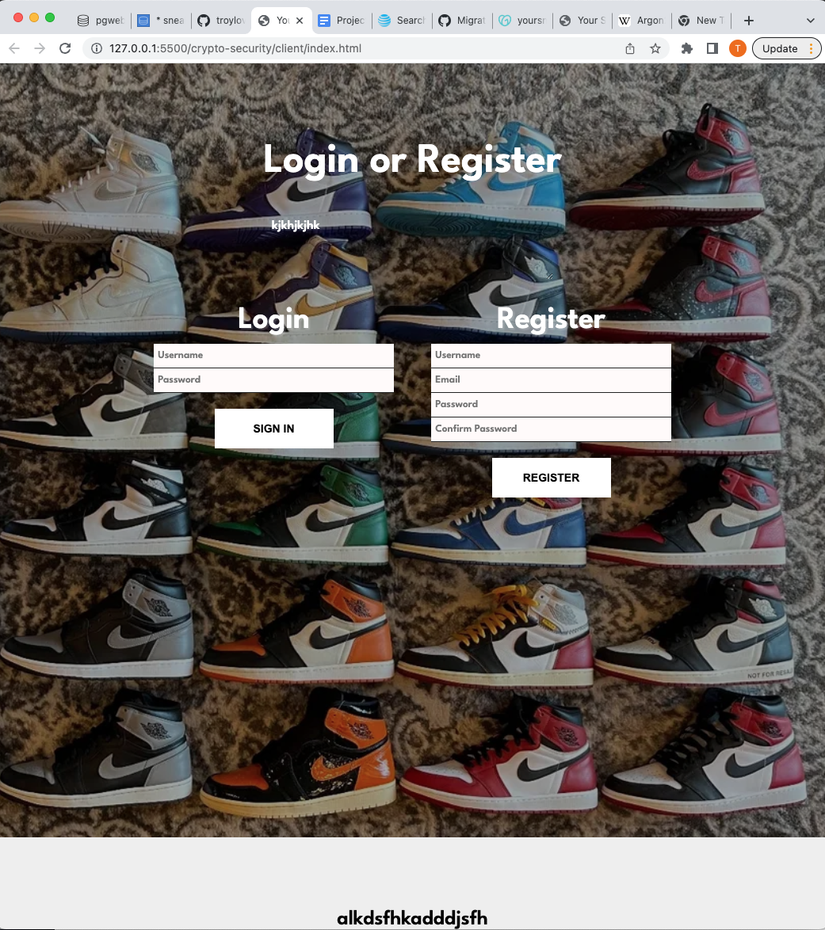

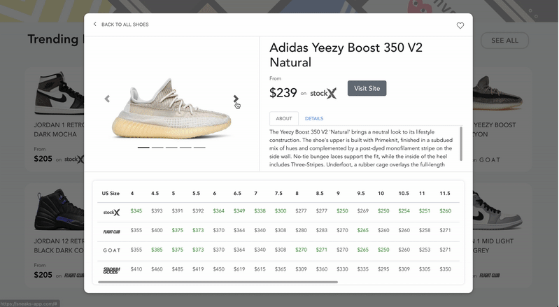

**Figures 2 & 3 : The registration/login page and “View All” shoes page**

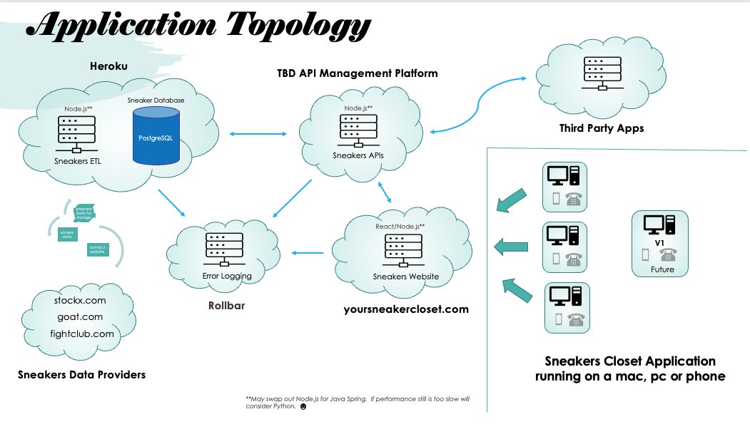

**Figure 4: Application topology**

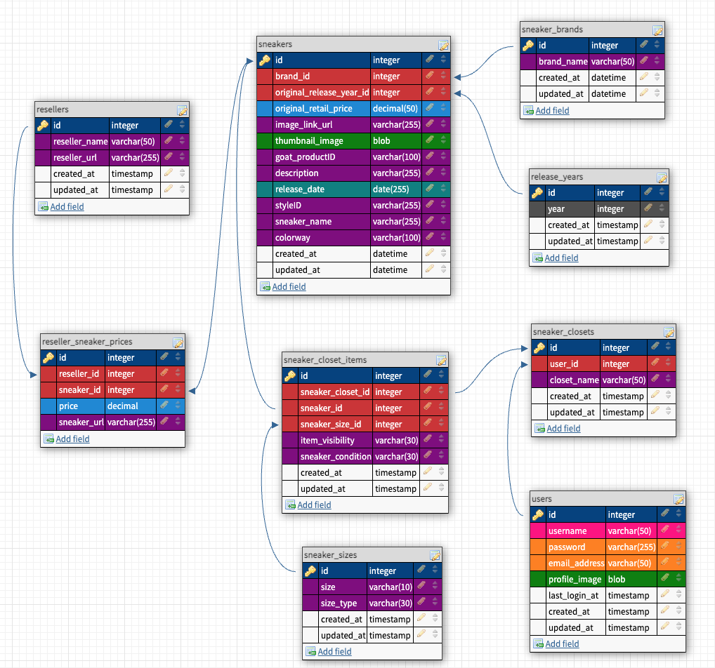

**Figure 5: Sneaker Database design**